Система за определяне на степента на дигитализация на (висше) училище
Христо Белоев, Ангел Смрикаров,
Валентина Войноховска, Цветомир Василев, Галина Иванова

A system for determining the degree of digitization of a (higher) school
Hristo Beloev, Angel Smrkarov,
Valentina Voinohoska, Tzvetomir Vassilev, Galina Ivanova

Abstract:
The pandemic has worsened the quality of the educational process but it forced us make a jump in the digitalization of this process, and it happened everywhere - in all schools and universities. So today it is reasonable to talk about determining the degree of digitalization of a (higher) education institution, which will be the topic of the presentation. Here, the word "higher" is not accidentally placed in brackets. Thus, we want to show that we will also be able to use this system to determine the degree of digitalization of a school. In fact, we will offer a system of indicators for the degree of digital transformation of the university, most of which are quantitative, but there are also qualitative ones.
An advantage of this system is that the value of the two integral indicators does not depend on the size of the higher education institution. Under this system, a small university could receive a higher grade than a large one. Disadvantage of the system is the need for careful verification of the value of quantitative indicators by an expert group.
Keywords: ……………………….….

For contacts: Academician DSc Hristo Beloev, University of Ruse, HBeloev@uni-ruse.bg

ВЪВЕДЕНИЕ
.............................................................................................................................................................................................................................................................................

ИЗЛОЖЕНИЕ
.............................................................................................................................................................................................................................................................................

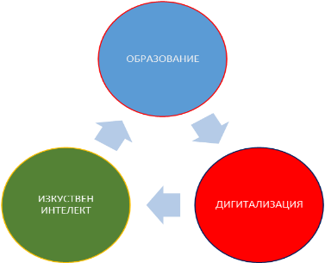

Фиг. 1. Релация - образование, дигитализация и изкуствен интелект.
.............................................................................................................................................................................................................................................................................

ЗАКЛЮЧЕНИЕ
.............................................................................................................................................................................................................................................................................

ЛИТЕРАТУРА
[1] ..............................................................................................................................
[2] ..............................................................................................................................
[3] ..............................................................................................................................

Забележка: Всички заглавия в тази точка трябва да бъдат цитирани с номерата им в текста на доклада.

